Project Design Phase-II
Technology Stack (Architecture & Stack)

Date | 31 January 3035
Team ID | LTVIP2026TMIDS41308
Project Name | Online Payment Fraud Detection With Manchine Learning
Maximum Marks | 4 Marks

Technical Architecture:
The Deliverable shall include the architectural diagram as below and the information as per the table1 & table 2
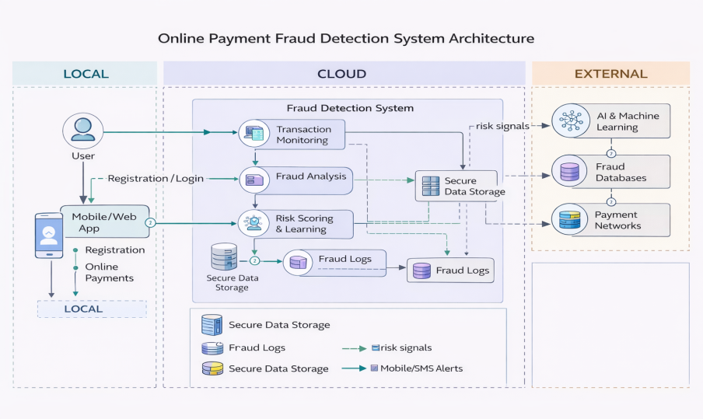

Table-1 : Components & Technologies:
S.No | Component | Description | Technology
 | User Interface | Web dashboard where users/admin monitor transactions and fraud alerts | Streamlit, HTML, CSS, JavaScript
 | Application Logic-1 | Backend logic for transaction processing, fraud scoring, API handling | Python, FastAPI
 | Application Logic-2 | Real-time fraud detection pipeline and feature processing | Python (Pandas, NumPy)
 | Application Logic-3 | Machine Learning inference service for fraud prediction | Scikit-learn / XGBoost
 | Database | Stores users, transactions, fraud results | MySQL / PostgreSQL
 | Cloud Database | Optional cloud-hosted database for scalability | MongoDB Atlas / Cloud SQL
 | File Storage | Stores trained ML models, logs, uploaded datasets | Local File System / AWS S3 (optional)
 | External API-1 | Payment gateway transaction verification | Stripe API / Razorpay API
 | External API-2 | Notification service for fraud alerts | SMTP Email API /Twilio
 | Machine Learning Model | Detects fraudulent transactions using historical patterns | Random Forest / XGBoost
 | Infrastructure (Server / Cloud) | Deployment environment for full application | Local Server (Dev), Docker, AWS / Azure / GCP

Table-2: Application Characteristics:
S.No | Characteristics | Description | Technology
1. | Open-Source Frameworks | Frameworks used to build UI, backend, and ML pipeline | Streamlit, FastAPI, Scikit-learn, Pandas
 | Security Implementations | Protects user data and transactions | JWT Authentication, HTTPS, Password Hashing (bcrypt), OWASP practices
 | Scalable Architecture | Microservice-ready architecture separating UI,API,and ML services | FastAPI microservices, Docker containers
 | Availability | Ensures system is always accessible | Cloud deployement,Load Balancer,Health checks
 | Performance | Handles high transaction throughput with low latency. | Async FastAPI, Caching (Redis optional), Efficient ML model

